**TFS Titan Krios G4 TEM**

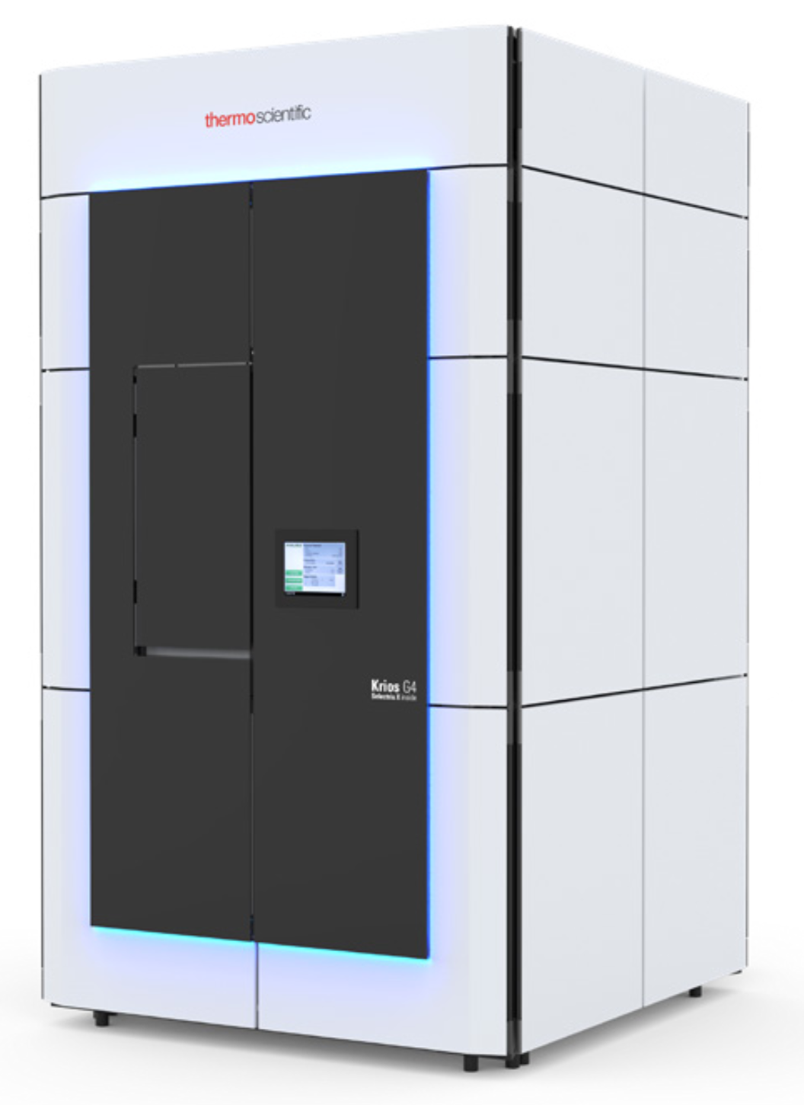

**Configuration**

The Titan Krios G4 from Thermo Fisher Scientific is a high-end transmission cryo-electron microscope designed for ultimate performance and productivity across a wide range of Life Science applications.

E-CFEG, (Cold FEG Gun) for low energy spread (<0.3 eV)

12 sample autoloader, aberration-free image shift (AFIS) and fringe-free imaging (FFI)

Fitted with a dedicated Selectris X Energy Filter with a Falcon 4i direct electron detector and a Ceta 16M Camera.

EPU and Tomo5 and Tomo Live software are used for data acquisition and on the fly data assessment. Data management (via a DMP sever) is delivered using Athena, with Smart EPU and Quality Monitor software

**Application**

Top of the line cryo-TEM optimised for highest resolution data collection single particle and cryo-electron tomography. This enables the 3D visualisation of proteins and molecular complexes at the atomic level with the ability to further localize the molecular architecture of a cell in a close to native environment.

**Titan Krios G4 Key Specifications**

|  |  |
| --- | --- |
| Electron source | E-CFEG |
| TEM Info Limit (nm) | 0.12 nm at zero specimen tilt |
| Cs | 2.7 mm |
| Falcon 4i DQE | (0 Nyquist) = 0.92 at 300 kV |
| Detectors | Falcon 4i fitted on a Selectris X TFS Imaging Filter.  4096x4096 pixels, 5.7cm2, 14 μm2 physical pixel.  320 fps internal frame rate.  EER (electron event representation),MRC, Tiff formats.  Thermo Fisher Scientific Ceta 16M CCD  4096 x 4096, 14 µm pixel  16 bit dynamic range |